**Jacob’s Well**

**November 2017**

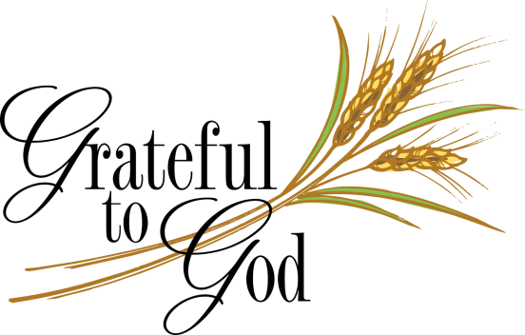

**Nov. 5 TWENTY-SECOND SUNDAY AFTER PENTECOST Celebration of the Lord’s Supper**

**Lectionary Readings:** Joshua 3: 7-17; Psalm 107: 1-7,33-37; 1 Thessalonians 2: 9-13;

Matthew 23: 1-12

Greeter: Joan Lapitsky

Liturgist: Anne Mitchell

Ushers: Karl and Kim Thayer

Counters: Cindy Brockman/Bruce Guerineau

Communion Servers: Anne Mitchell/Cindy Brockman/Paulette Foote

Communion Cleanup: Pam Seward

**Nov. 12 TWENTY-THIRD SUNDAY AFTER PENTECOST**

**Lectionary Readings:** Joshua 24: 1-3, 14-25; Psalm 78: 1-7; 1 Thessalonians 4: 13-18;

Matthew 25: 1-13

Greeters: Patti Booth

Liturgist: Bruce Guerineau

Ushers: Hank and Katrina Harrington

Counters: Paulette Foote/Amber Deyoe

**Nov. 19 TWENTY-FOURTH SUNDAY AFTER PENTECOST Thanksgiving Sunday**

**Lectionary Readings:** Judges 4: 1-7; Psalm 123; 1 Thessalonians 5: 1-11; Matthew 25: 14-30

Greeter: Bill Olmert

Liturgist: Hank Harrington

Ushers: Makenzie Harrington/Terri Richards

Counters: Anne Mitchell/Bruce Guerineau

**Annual Congregational Meeting following worship**

**Nov. 26 REIGN OF CHRIST SUNDAY Fellowship Hour hosted by the Woomers**

**Lectionary Readings:** Ezekiel 34: 11-16, 20-24; Psalm, 100; Ephesians 1: 15-23;

Matthew 25: 31-46

Greeter: Amber Deyoe

Liturgist: Paulette Foote

Ushers: Paula Sheely/Bridgette Lewie

Counters: Cindy Brockman/Amber Deyoe

**New Members Orientation following worship**

**From the Pastor..**

“**There is one body and one Spirit...**

**one Lord, one faith, one baptism,**

**one God and Father of us all,**

**who is above all and through all and in all.”**

**(Ephesians 4:4)**

Dear Members and Friends of Old Saratoga,

Greetings to you in the grace and peace of Christ!

This coming Sunday, October 29, we will commemorate the 500th Anniversaryof the Protestant Reformation. The actual date is October 31 (All Hallows Eve) which marks the date in 1517 when **Martin Luther** nailed his 95 theses to the door of the Wittenburg Church in Germany, to express his grievances about the teachings and practices of the one church at that time—the Holy Roman Catholic and Apostolic Church. We've been learning more about our Reformation church history these past Sundays in October as our church historian, **Dick Behrens,** has taught us, young and old together, about the when, who and why of the Reformation!

Commemorations such as these are times to not only look back, but to look forward. Thus, 500 years later, we're asking the question of what needs re-forming in the church today, in order that the church can be a community of grace, and how we (Protestants and Catholics) can overcome division and be one—so the Reformation can come full circle. How can we better make “every effort to maintain the **unity of the Spirit** in the bond of peace?” (Ephesians 4:3)

On November 1 (All Saints Day), our new “fellow” in ministry, **Jennifer Legg** will begin her two years of work with **Old Saratoga, Bacon Hill, and Fort Miller Reformed Churches**. Already there are signs of re-formation, as the churches have prepared for her coming: There's been more conversation between the churches, more meetings bringing people together that didn't know each other before; and there's a genuine desire to collaborate—to work together in new ways that we hope will help strengthen and renew the church of Jesus Christ; and help us, by God's grace, to be people of the Word, who reach out in faith, love and compassion to make a difference in our community and world.

We have much for which to be thankful—including the opportunity to participate with our sister churches in the Albany Synod Fellowship Program; the joy of welcoming Jennifer Legg who is excited to begin her work and ministry among us; the ecumenical fellowship we share with the other churches in our community; and the continuing love, service and prayers of Christ's people for the church and community!

**Faithfully yours,**

Pastor Joyce deVelder

**Church Family**

**BIRTHDAYS**

1: Roger Sherman

2: Carol Burch

3: Roger M. Sherman

3: David Woomer

6: Wendy (Russell) Fedderly

10: Emily Buchanan

11: Lily Russell

12: Robert Haney

12: Thomas Pooler

13: Peggy MacMillan

14: Sawyer Russell Fedderly

18: Linda Barter

20: Melanie (Whitehouse) Casey

22: Danny MacMillan

22: Sandy Jones

23: Ryan Markwith

24: Chauncey Mabb

24: Allison Cummins

25: Timmy Cox



**ANNIVERSARIES**

9: Donald and Kimberly Mac Millan, 2002

10: Anne and Doug Mitchell 2012

25: Bill and Duffy Whitehouse, 1967 **(50!!!)**

**Please help us keep the lists current by giving us**

**dates and updates. Thanks!**

**CHURCH OFFICE CLOSED**

The church office will be closed from

Nov. 22 through Nov. 24, reopening on Monday, November 27.

**THANKS EXTENDED**

**IN OUR PRAYERS**

***“Pray at all times in the Spirit….making supplication***

***for all the saints.” (Ephesians 6: 18)***

Ruth Hayes Bette Tucker

Dwight Colvin Sue and Tom Wilbur

Alyson Fitzgerald Bill Cluff

Thomas Altrogge Venita Duffany

David Garrand Ryan Markwith

Rod Borgman Margaret Hougen

John Bodnar Trevor Lewie

Richard Zelazny Naomi Thayer

Cheryl Jones Cheryl Durkee

Evie Senecal Alicia Lewie

Charlotte Gorham Rosie Driscoll

Justin Flanders Clyde Wells

Susie Murphy Tom Barber

Jim Miers Michael Hughes lll

Sandy DeGregory Charles Thayer

Mona Perkins Barbara Vincent

Suzanne Guerineau Joan James

Trisha Atkinson Danny MacMilllan

Michael Gordon Jodi Neckles

Peggy MacMillan Ken Howe

Donald Morrill Florence Sherman

Katrina Harrington Joy Yahwak

Susanna Combs Robin Woomer

**THANKS RECEIVED**

“Thank you so much for your beautiful hospitality towards me as I visited NY. I truly appreciate everything you all did for me with providing me a place to stay while I visited, took me to lunch, and showed me around. I loved that I was able to see you all at work doing ministry throughout the week while I was there especially the garage sale. It was such a blessing to meet you all, and I can’t wait to come back to do ministry with you all. I am planning on being back the week of Oct. 22 to move in. I am looking forward to seeing you all soon.”

**Love, Jenn Legg**

**(Albany Synod Ministry Fellow)**

**THANKS EXTENDED** 

..to our **anonymous friend** who has again donated 200 postage stamps

..to **Dave Garrand** who has mowed the church lawns all summer and cleaned up all the leaves

..to **Dick Behrens** for his interesting and informative “Reformation Moments” during

All God’s Children, on the Sundays of October, leading up to the commemoration of the 500th Anniversary of the Reformation on Oct. 29, and to **Anne Mitchell**, who filled in for her father when he had another commitment

**MARRIAGE**

Blessings and congratulations to **Stephen** **Charles Bodnar** and **Michelle (Shelly)** **Anne Dwyer**, who celebrated their marriage on Sunday, Oct. 8 at the 1925 Barn in Hudson Falls. **Pastor Joyce** officiated at the ceremony.



Stephen is the son of **Joan and Steve** **Bodnar.** Shelly is the daughter of **Anne** **(Boivin) Dwyer**. Stephen and Shelly live at the Bodnar Farm (165 Hanehan Road in Schuylerville, where Stephen works as a dairy farmer. Shelly is employed as a dispatcher, and helps out on the farm. May God bless them with many happy years together!

**PSALM 100**

**A Psalm of Praise**

**Make a joyful noise unto the Lord,**

**all ye lands.**

**Serve the Lord with gladness; come before his**

**presence with singing.**

**Know ye that the Lord he is God: it is he that hath made us, and not we ourselves; we are his people, and the sheep of his pasture.**

**Enter into his gates with thanksgiving, and into his courts with praise:**

**be thankful unto him and bless his name.**

**For the Lord is good; his mercy is everlasting; and his truth endureth to all generations.**

**(KJV)**

**A Blessed Thanksgiving to all!**

**Thursday, Nov. 23**

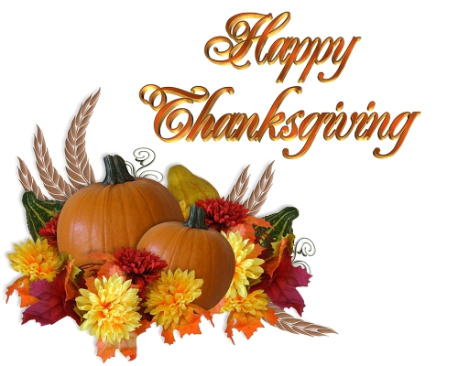

_________________________________________

**DANNY MacMILLAN FUND**

**Danny MacMillan** is a 13 year old boy who has been diagnosed with Ewing’s Sarcoma.

He has family ties with OSRC. A helping fund has been set up to receive donations for the family. Checks can be made payable to “Team Dan Dan” and sent to Glens Falls National Bank, 73 Broad Street, Schuylerville NY 12871.

**SAVE THE DATE**

**Spaghetti Dinner**

**Benefit for Danny and Family**

**Sat. Dec. 16 5-8pm Take-outs available**

**Schuylerville School Cafeteria**

**HARVEST SUPPER**

#### **SAT. NOVEMBER 4**

**4:00pm through 6:00pm**

**(continuous serving)**

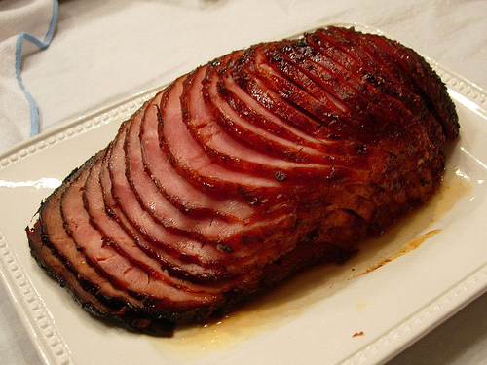

**OLD SARATOGA REFORMED CHURCH**

**48 Pearl Street**

### Schuylerville, NY

**Menu: Baked Ham, mashed potatoes and gravy, squash,**

**green beans, Dutch Kraut, rolls & butter,**

**homemade Apple and Pumpkin pies, beverage**

**Adults $10 Children 5-12 $5 Under 5 free**

**Dine in or take out**

**Reservations Recommended**

**Call 695-6638**

**or the church office (695-3479)**

**Call 695-6638 or 695-6187**

**or the church office**

**at 695-3479 M-F 9-12**

## 

## 

(For more information call 695-3479, M-F, 9 AM- 12 PM)



**Church Life**

**OSRC ANNUAL MEETING**

**Sunday, Nov. 19**

The annual Meeting of the Old Saratoga Reformed Church will be held on Sunday, Nov. 19 immediately following worship. Deacon and Elder nominating forms are available on the back table of the sanctuary. Those nominations will be voted on at the meeting. The 2018 Plan for Ministry (budget) will also presented for approval. Refreshments will be provided by consistory members. Please plan to stay and be a part of our church’s spiritual and financial planning for 2018.

**CAFÉ MUSICA CANCELLED**

Due to scheduling problems, the Café Musica, originally to have been held on Sunday, Nov. 12, has had to be cancelled. It will be rescheduled for some time after the holidays.

**COMMUNITY CHRISTMAS CONCERT**

**Sunday, Dec. 3 at 3pm**

Plans are under way for the Annual Community Christmas Concert to be held at Old Saratoga. Area choirs will again each sing an anthem, and there will be audience carol singing in between. Refreshments will follow the hour long concert. Please come and get in the Christmas spirit by attending with your neighbors and friends in Schuylerville!

**A free will offering will benefit**

**Danny MacMillan and Family.**

**ECUMENICAL BIBLE STUDY**

Bible Study meets on **Wednesdays at 10am**

in Loomis Hall. The group will be continuing their study of Isaiah. New members of any denomination are welcome to join.

**WOMEN’S GUILD**

The Guild will meet on **Tuesday, Nov. 14 at noon.** Hostess for the month will be **Joan Lapitsky.** Bring a sandwich; dessert and a beverage will be provided. **Note change in day /date!!!!** The guild will hold their annual Christmas Dinner and party on Mon. Dec. 18.

**CHANCEL CHOIR**

The choir meets to rehearse on **Thursdays at 7pm.** New voices are always welcome.

**OSRC HAS NEW E-MAIL ADDRESS!!**



**oldsaratogareformed@gmail.com**

**HARVEST SUPPER**

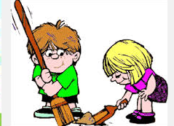

We will need everyone’s help to make this fundraiser a success. That includes buying a ticket or two, telling your family and friends how good the food is, and urging them to come, and **especially** sticking around to help with cleanup (or coming specifically for that!) as many people who have been helping during the day are tired and could use some new helpers then!

**St. Nicolaas Holiday Sale**

**at Old Saratoga Reformed Church**

**(corner of Pearl and Burgoyne Streets)**

**Saturday, Dec. 2**

**8 am-2 pm**

**(to help celebrate Schuylerville's Celebration of St. Nicolaas)**

**Gently used Christmas decorations,**

**baked goods, fudge, basket raffles,**

**refreshments**

***(All proceeds will benefit the General Fund)***

***\*\*\*Please check your Christmas decorations for items which you no longer want and donate them to our sale!!\*\*\****

***Thank You!***

**OTHER LOCAL ST. NICOLAAS EVENTS Dec. 1-3**

**Memory Tree Lighting at the Saratoga Town Hall Fri. 6pm**

**Entertainment Events and Vendors all day**

**in the Town Hall on Saturday 10 am-4pm, Sunday 10 am-2pm**

**Community Christmas Concert Sun. 3pm at**

**Old Saratoga Reformed Church**

**HYMNS OF OUR FAITH**

**“Sing to the Lord, you saints of God; praise**

**his holy name.” (Psalm 30:4)**

**“My hope is built on nothing less than Jesus’ blood and righteousness.**

**I dare not trust the sweetest frame, but wholly lean on Jesus’ name.**

**On Christ the solid rock I stand; all other ground is sinking**

**sand; All other ground is sinking sand.”**

“The Solid Rock” finds a biblical basis in 1 Corinthians 3:11. “For no one can lay any foundations other than the one already laid, which is Jesus Christ.” It also brings to mind the words of Acts 4:12 – “Salvation is found in no one else, for there is no other name under heaven given to men by which we must be saved.” The idea that God alone can forgive our sins and bring us to eternal life is a bed rock tenet of our reformed faith.

This hymn, originally titles “The Immutable Basis of a Sinner’s Hope” was written by Edward Mote, to bring solace to his sister-in-law who was gravely ill. William Bradbury, who wrote the music, was a noted musician and choir director, and composed the hymns, “Jesus Loves Me,”” Sweet Hour of Prayer” and “Just As I Am.” Bradbury, a native of Maine and educated in Boston and Germany, was called to be choir director and organist to a church in Brooklyn. His youth choirs sometimes had as many as 1000 voices, leading school administrators and Sunday School superintendents to visit. Bradbury’s work led the public to see the necessity of musical instruction in the schools, and he had the satisfaction of seeing music taught as a regular study in the NYC public schools.

Bradbury’s melodies have an easy, natural flow, and his harmonies are simple. Many of his hymn tunes and gospel songs are among the best that American composers have produced. **Dick Behrens**

**Dick Behrens**

**Dick Behrens**

**Dick Behrens**

**Dick Behrens**

**Dick Behrens**

**Dick Behrens**

**PROPERTY COMMITTEE REPORT**

The Property Committee met on 10/16 and updated the progress of the items on which they have been working:

1. **Doug Sheely** will soon complete the painting and repairs at the parsonage
2. Emergency lights have been installed in the church building per the building inspector
3. **Doug Sheely** will plow the driveway this winter as a donation to the church. **David and Mikael deVelder** will clear the sidewalks
4. A new toilet has been installed in the upstairs bathroom of the parsonage
5. Extended thanks to **Dave Garrand** for mowing and mulching the church lawns
6. The committee welcomed **Oscar Everts** as a new member

**Next meeting is Mon. Nov. 13 at 7pm.**

**MISSION OF THE QUARTER**



The Heifer Project works to help lift families out of poverty through the donation of farm animals, and training recipients in their use and care. The aim of the training is to achieve sustainability. The donation of farm animals also focuses on food security and nutrition. The Heifer Project can be found in the US and internationally. For more info visit www.heifer.org

**Boxes for donations are available for filling and will be returned to the church**

**December 17.**

**TUESDAY COFFEE TIME 9:30-10am**



The Tuesday morning coffee hour will continue this season, from 9:30-10am. **All** are welcome to come, sit around the table, have a “goodie” and coffee, and enjoy some conversation!

**PECANS**

It may seem a little early to be thinking about holiday baking, but OSRC has again ordered pecans from Georgia to purchase for baking and snacking. Pre-ordering is suggested. We order two cases of pecan halves, and two cases of chocolate covered pecans, so it’s best to get your request in soon! A list is available for you to indicate what you’d like to order, or you may call the office (518-695-3479)

**ADVENT WREATH**



The Advent Wreath signup sheet is posted in the foyer. Families, groups of friends, or individuals may volunteer to light the candles on the Sundays of Advent, at the start of the worship service. Materials are provided for you and will be in the foyer to pick up. The first Sunday of Advent is **Dec. 3.**

**SUNDAY SCHOOL NEWS**



Sunday School for children in grades K-5 will be held **November 12th – December** **10th** when the children will present a special Christmas message during the worship service. We look forward to seeing the children from last year and welcome new children to join us.

**NEW MEMBERS ORIENTATION**

**Sunday. Nov 26 following worship**

The Elders met and planned a New Members Orientation. Several individuals have expressed an interest in membership in Old Saratoga. People can become members by Baptism, Profession of Faith, or by Transfer of Letter from a church where one is already a member.

The orientation is on Sunday, Nov. 26 after worship, with lunch and conversation about the church and what’s involved in membership. The pastor and elders look forward to getting to know people who are interested in uniting with the congregation.

**ST. NICOLAAS BRUNCH**

**Sat. Nov. 25 10:30am**

Everyone is invited to come to the St. Nicolaas Brunch on Sat. Nov. 25 at 10:30am to help decorate the church for the Christmas Season. First we will join together for the meal, and then do the decorating of the sanctuary and Loomis Hall. Please bring a brunch item (sweet breads, muffins, egg casseroles, fruit, juice, meats) to share. See you there!

**POINSETTIAS**



Poinsettias can be ordered through the church to memorialize or honor a loved one this Christmas season. Cost is **$10** per red plant. They will be displayed on Christmas Sunday, Dec. 17, and Christmas Eve. Forms are placed in the bulletins on Sunday, or you may call the office to order.

**Deadline is Nov. 26.**

**INTRODUCING JENNIFER LEGG**

**Albany Synod Fellowship Program**

**Fellow in Ministry**

Jennifer Legg will begin serving the three RCA churches (Old Saratoga, Bacon Hill and Fort Miller), on Nov. 1. On Oct.21, Jenn, with the help of her parents, moved to from North Carolina to Greenwich, a coming home of sorts as she was born and lived in the Kingston area for 11 years.

Jenn earned an Associate degree at Wake Technical Community College and a BA in religion from Campbell University, going on to study at Western Theological Seminary, and graduating with a Masters of Divinity in 2011. For the past six years she has worked in the Raleigh, NC area as a manger of a Starbucks. She was ordained as an elder in her home Reformed Church in Cary, NC, and was actively involved in ministry there.

Jenn just received the news that the Classis of Mid-Hudson approved her contract and will ordain her to the Ministry of Word and Sacrament on Sunday, Nov. 12 in her home church in Cary, NC.

Jenn identifies her three main passions for ministry as leading worship, pastoral care and outreach. She sees her role as “servant leader,” following the example of Christ. She describes ministry as “equipping and connecting the church with the community that surrounds it.”

When Jenn visited in September, we were impressed with her love of people, and her easy, friendly manner. Now that she is here, we look forward to getting to know her better and working side by side with her in a collaborative way that will benefit her, the congregations and the greater community

**HELP NEEDED IN PUERTO RICO**



The consistory asks your help for monetary donations to send to the **Palmas Community Church,** a small English speaking congregation in Puerto Rico, located 45 minutes from San Juan.

**The Rev. L’anni Hill** (long-time friend of the deVelders who served a pastorate in Puerto Rico) has been in touch with Pastor Joe Ramos of the Palmas Congregation, who wrote the following to us on Oct. 19 (4 weeks after Hurricane Maria struck.)

“Humacao suffered far more than San Juan since it was in the direct path of the hurricane. He (Pastor Joe)said there is **tremendous need** in Humacao and the surrounding villages – still no electricity and FEMA hasn’t provided the blue tarps to cover blown-off roof areas, so now the rains are coming in on the houses people are trying to live in.”

We ask your prayers for **Pastor Joe**, his wife **Elilda**, and the Palmas congregation, as they work together to help people in their community through the long recovery process.

If you would like to give a donation, please make your check payable to “OSRC” and earmark “Palmas Church-PR”

All donations will be sent directly, by our church treasurer Chris Garney, to the Palmas Community Church.

**In Our Community**

**OLD SARATOGA SENIORS**

The Seniors are welcoming new members 55 and older. Dues are $7 a year, Sept. –June. Meetings are held in the Town Hall on the 1st and 3rd Wednesdays at noon. Come have fun mingling with others, listening to entertainment or doing a day trip!

**__________________________________________**

**FORT MILLER PORK SUPPER**

**Saturday, Nov. 11 4:30-6pm**

**Adults: $12; children 6-12: $6**

**Call Tina DeJong 518-747-8011**

**______________________________________**

**BACON HILL LASAGNA DINNER**

**Sat. Nov. 11 - 4:30 and 5:45 pm seatings**

**Adults: $10; Children under 12: $5**

**Reservations recommended**

**Call 518-695-6116**

**Take outs from 4:15-6pm**

**__________________________**

**SAFER FUNDRAISER - Fri. Nov. 3**

**at the Glens Fall National Bank**

Be sure to stop by the Glens Falls National Bank from **10am-4pm on Friday, Nov. 3** to find out more about SAFER (Schuylerville Area Food Relief) and how you can support this vital program for residents of the Schuylerville School District.

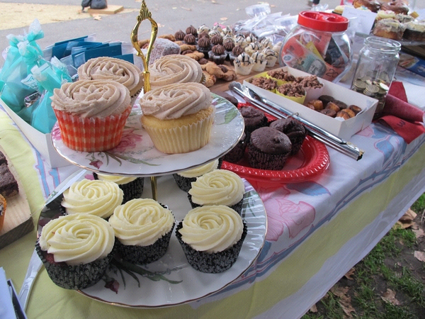

**Volunteers are needed to help make goodies for the bake sale table.**

**You can drop off your donation at the bank from 9am-10am on Friday, Nov. 3.**

**Thank you!**

**SECOND HAND ROSE THRIFT SHOP**

**116 Broadway, Schuylerville NY**



**Tues. – Sat. 11am-4pm**

**Donations gladly accepted during store hours**

**Volunteers are always needed!**

Call Charlotte at 518-695-4640

**Next Board meeting: Nov. 10 at 9:30 at OSRC**

________________________________________________

**SAFER**

**(Schuylerville Area Food Relief)**

**12 Spring Street**

**Open 9-12 noon M,F 518-507-6043**

**________________________________________________**

**BATTENKILL CONSERVANCY SPEAKER**

**“A Journey Down the Hudson”**

**with Doug Vincent**

**Sunday, Nov. 5 at 2-4pm**

**at Fort Miller Reformed**

**Slide show and presentation**

**Refreshments and seasonal snacks**

**All welcome – public invited!**

**Info: Lorraine Ballard 518-658-3589**

**WREATHS ACROSS AMERICA**

Wreaths Across America is an organization that helps raise money to provide a wreath for each veteran’s gravestone. Currently there have been **2047** wreaths **(20%)** donated; the goal at the Gerald B.H. Solomon National Cemetery is 10,000 wreaths. Visit **WreathsAcrossAmerica.org** for more information, to donate, or to register as a volunteer. **Cost is $15 per wreath**.

**On Saturday, Dec.16, 2017 at 12 noon,** **a ceremony will be held and wreaths will be placed. A group from OSRC is planning to help. See Cindy Brockman.**

Church Office: 695-3479

E-Mail:oldsaratogareformed@verizon.net

Fax: 1-518-695-3479

[www.old-saratoga.rcachurches.org](http://www.old-saratoga.rcachurches.org)

**OLD SARATOGA REFORMED CHURCH**

www.old-saratoga.rcachurches.org

oldsaratogareformed@gmail.com

www.facebook.com/oldsaratogareformedchurch

PASTOR: Rev. Joyce deVelder

OFFICE MANAGER: Duffy Whitehouse

**Consistory Members:** Amber Deyoe, Paulette Foote,

Cindy Brockman, Bruce Guerineau, Anne Mitchell

Published ten times yearly in Schuylerville, NY 12871

Sunday Worship: 10:00 am

Sunday School: (Nov. -Dec) 10:00am–11:00am

**Harvest Supper**

**Sat. Nov. 4 4-6pm (details inside)**

**Daylight Savings Ends (overnight Nov. 4-5)**

**Turn your clocks back one hour!**

**Celebration of the Lord’s Supper**

**Sunday Nov. 5 10am**

**OSRC Annual Meeting**

**Sun. Nov. 19 11:30am**

**St. Nicolaas Brunch and Church Decorating**

**Sat. Nov 25 10:30am (details inside)**